**Explaining the terminology**

Each Inspection Window has a start and finish time, known as the “Inspection Start” and “Inspection Finish”. However, the duration that the individual inspects the property is usually shorter than this window. This “Duration” is represented in red below within each of the boxes labelled “Early”, “Scheduled” and “Late”.

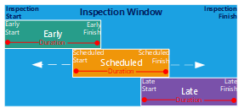

The first box labelled “Early” identifies the earliest time an inspection can start (Early Start) then based on the duration specified, the earliest time an inspection can end (Early Finish).

The third box labelled “Late” identifies the latest time an inspection can finish (which is both the Inspection Finish and Late Finish) then working backwards, using duration, the latest time an inspection can start (Late Start).

Finally in the second box “Scheduled” identifies the actual start time in the plan once the inspection is scheduled. This can range anywhere from the early start and finish to the late start and finish.

Understanding the difference between these three concepts allows for a better understanding effective approaches in inspection planning.

With only the inspection window and the duration of an inspection, we know the Early and Late details. This can be used to identify options for inspections following a given scheduled inspection, as we can see in Figure ??.

If the inspections are sorted by “Early Start”, following the Scheduled Inspection conclusion, this excludes Unscheduled Inspection #1, #2 and #3. Whereas if we sort by “Late Start” this captures these three inspections. Therefore for initial assessment, unscheduled inspections are sorted by “Late Start”.

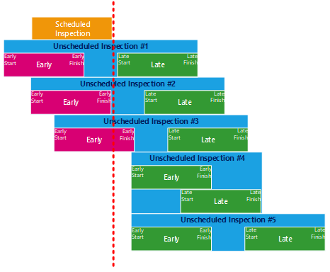

Next, each Inspection can be assessed for viability. Here we introduce travel time, which can only be calculated with knowledge of the scheduled inspection location. In Figure ?? each rounded rectangle “TT” represents the Travel Time. We can see that Unscheduled Inspection #1, #3 and #5 have become unviable as a result of their travel times from the previous “Scheduled Inspection”. Travel Time is considered using the naive approach to travel time for a window of the following 15 inspections (if there are less than 15, then the remaining inspections)

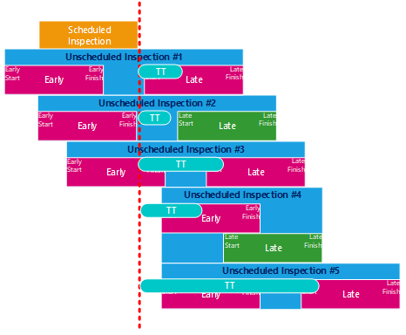

After Travel Time is considered, the Area Inspection variable is considered for each inspection, the area inspection is determined by grouping, and is covered in more detail in section ??. If an area has previously been inspected by a previous scheduled inspection, the duration does not count towards the total inspection time as seen in the below figure ?? denoted by the “Test” box. Unscheduled Inspection #2 *Area Inspection* has been satisfied by a previous inspection, whereas Unscheduled Inspection #4 has not. Note that an area inspection can be divided to occur both before and after the Late Start and Finish times as required.

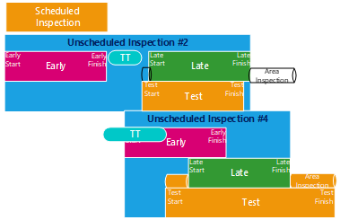

At this stage the next 5 inspections that are considered to be competitors will be further compared.

As we can see

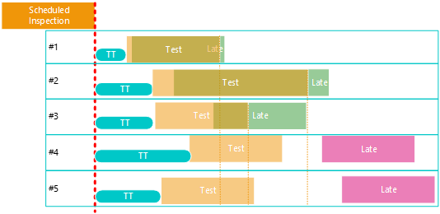

**Note:**

*Area inspection is always added before the late start, any left over time is appended to the end of the inspection time. If the Area Inspection is exhausted before Late Start, then an earlier inspection occurs. If the Area Inspection is exhausted before Early Start, then a wait time is introduced. The Scheduled Inspection duration spans the Area Inspection and the above timeframes.*

*The area inspection will not be traded between inspections, it will be applied to the first scheduled inspection of a group. This means a less than optimal solution may be present, where a later inspection has a wait time, and an earlier inspection finish is delayed by Area Inspection. Or the duration*

*always be considered for the first iteration*